DESIGN BRIEF

DESIGN PROBLEM

The issue of climate change is an important problem facing human and animal life today. Climate change as a global phenomenon is something that is both highly debated but also relatively ignored, considering how often it is actually referred to or discussed in the media. Much of what constitutes a “climate change debate”, however, is the rerelease of continuous streams of information regarding similar scopes of interest. Individuals find themselves bombarded everyday with articles or images that all seem to include the same words or phrases, and ultimately seem to be discussing the same issues with no apparent or relevant solutions.

As climate change is a complex issue, conceptual dimensions at play in our design challenge can be seen through the lack of awareness people have on the effects of climate change. The design challenge also creates a dimension of unconscious knowledge that the changing climate negatively harms people, the greater animal kingdom and ecosystems. People seem to have different levels of knowledge on the topic of climate change and are often times misled or misinformed due to a vast amount of unreliable resources that are seen constantly within our target audience. The biggest challenge that proponents of climate change face is surpassing this level of apathy that most people have developed towards the idea of climate change, and offering personal, concrete solutions to lessen its impact.

It is therefore crucial to change this paradigm in thinking and improve the ways a specific population accesses relevant information. Based on user interviews from our prototypes, we were able to see that most of our target audience, UCSD undergraduate students, are somewhat knowledgeable about issues facing climate change, but feel as if their individual actions to combat climate change are not impactful enough. We sought to make our design solution create a shift in the paradigm concerning an individual's knowledge and consciousness towards climate change.

Combating climate change is a difficult task and can be accomplished in various ways. We knew that it was important to consider the physical dimensions that our design challenge would encounter in the real world. Our team decided to make the university, UCSD, the design space. Considering the college campus as the setting for our design challenge meant that our group had to account for the sheer size of the space and number of students. Part of this challenge included overcoming the obstacle of reaching a huge student population, and then changing their mindset towards the climate. Since UCSD has a high number of enrolled undergraduates, it made sense for us to take advantage of the number of students for our design solution, while also recognizing that UCSD has six different colleges with varying amounts of students living on and off campus. In our initial interviews we found that students perceive that climate change is real but fail to take any actions to change habits that are detrimental to the environment. Our aim is to persuade students to be active in tackling climate change so that they will, in turn, continue to build upon these practices and influence more people to be environmentally conscious. The physical space that will then be used includes on campus housing, off campus housing, and any space that is taken up by the individual in and out of class.

Climate change is an issue that affects human life at different social levels. The social dimensions of the design challenge include coming up with ways to get undergraduate students interested in knowing about their ecological footprint, combating any political ideologies that are detrimental to progressive climate change, getting people to build a awareness for their individual impact, and shifting existing paradigms in ideologies so that individuals can feel a greater sense of urgency for combatting the issue. Marketing our solution would have to be well thought out as we found through initial interviews that the subject of climate change, while appealing, is not a practical one. In the social realm of the design challenge, thinking about the current political climate is important to include in the design solution as the current executive administration is against the idea of climate change. These existing institutions can therefore affect how UCSD students think and react to climate change. Considering more target audience interviews, we realized that we needed to design a solution to the problem that would allow the user to become informed on the subject first, and then enable them to start changing individual habits to benefit the climate. User interviews also revealed that most students value their time out of class, so it was crucial to find a way to shift people’s perspectives on the climate through undisruptive ways and minimal effort from users.

TARGET AUDIENCE

We collected initial data for our design challenge to better understand where our design solution would best fit considering the different social, physical, and conceptual dimensions of our problem. We collected data through interviews, polls, and surveys completed both online and in person. Most of the conducted interviews were completed on the UCSD campus at times that were most convenient to the interviewee. We collected data by asking questions about their knowledge on climate change, observing interactions between users and the environment, as well as follow up interviews after observing to analyze why they did what they did.

Our target audience encompasses the general sphere of all university students. However, we have specifically directed our efforts towards the undergraduate students at UCSD. According to statistics from the 2016-2017 academic school year, our audience here consists of approximately 35,816 undergraduates. This is inclusive in terms of about 13,507 female, and 14,554 male students. The individuals taken into consideration include those who are housed both on campus and off campus.

We have found that many college students are surprisingly uninformed with regards to climate change, upon entering the university. While they do know some general information, little-to-none of what they understand is considered “dire enough” to relay any permanent or lasting changes in practice. In fact, despite the general consensus that it exists, university students still struggle with gauging how much of an impact climate change actually has on their lives. Human beings operate on sensory-level analyses of their experiences, knowledge, and awareness. Most students are relatively unaware of, or apathetic towards just how much of their lives are actually affected by climate change, because its effects are “invisible.” The fact that climate change has such a minimal effect on the “five senses” is a key issue regarding its view as a relatively unforeseen and harmless threat. Additionally, we have observed that for students, education almost always comes first. Due to busy and rigorous work or school schedules, university students are usually unwilling to be flexible beyond their predetermined routines and activities. Inclination for action appears to take place only if they are guaranteed to cause immediate changes, and if results do not have any inconvenient effects on daily life.

There also exists a natural social inclination for imitation and repetition amongst people that coexist in the same social atmospheres, in this case, namely college campuses. The unspoken principle of “If everyone else is ignoring something, then so can I” has much more precedence than people tend to consider. This social construct causes people to unconsciously follow one another; if a large group of people appear to do one thing, the rest are sure to follow, regardless of what it may be.

Demographically, this target audience embodies similar life goals and directions, at this particular life stage. Almost all students desire to graduate from their respective universities within 4 to 5 years. Most are either not very interested or only moderately interested in changing their habits to benefit the environment. This is also not a very sustainable group of people, as students almost always allocate their lifestyle around convenience and efficiency, rather than sustainable living. Due to workload, constant pressures, and stresses, university students are also generally more inclined to view the smaller picture of grades and graduating as having more value than a future with a clean environment.

Climate change is specifically relevant to university students, because students *are* the future. These individuals are the ones who will use their current work to make differences later on in workplaces and communities. Despite the fact that average opinions may vary across campuses, college students all have a single thing in common: the ability to make a difference by altering their own lives. For example, by nature, college students are affected most by their educational goals. Undergraduates can now major in environmentally sound fields of academia such as environmental science, engineering, or policymaking. One article stated that “students also express their concern for the planet through green majors such as environmental science, sustainability and environmental policy” (Vendituoli). Providing our college students with more opportunities to consider climate change parallel to their educational objectives is a key way of eventually reaching out to those beyond just the college student demographic.

Environmental activism is also sparked by higher levels of socio-political understanding. American public universities are generally known for being radically free and open-minded spaces. Students have the opportunity to receive exposure to multitudes of differing ideologies, standards, and even occupations. According to one study, “college students represent a unique subset of the population because of their exposure to climate topics in school, recent exposure to catastrophic disaster events, and their position as future leaders and policymakers” (Phillips, et al.). The dimensions of a college student body are therefore incredibly large, diverse, and malleable. They hold our potential for changing the future.

SOLUTION

Our first prototype was that of a course syllabus made for a 10 week course plan that served to inform students about climate change and required them to actively construct a method of conservation and awareness of their ecological footprint written in a graded journal. We felt this design solved the main problems we were targeting by informing students, allowing them a creative space to participate in a better environment actively, and because it would be a class, students would have more incentive and motivation to do well.

Our second prototype was a parallel design for a workshop at UCSD. Some of our team members focused on prototype testing 4 different topics to see if students found “Climate Change” an important or interesting topic in comparison to others. The other prototype tested a range of course ideas for Climate Change, to see what aspects of climate change were interesting to students. We also gained insights about the different topics within climate as people were asked to explain why they chose certain options.

From testing the prototypes, we decided a quarterly workshop would be the best solution at the moment. The workshop would have slides that people would be able to view, guest speakers explaining more in-depth content, sections within the event where people will interact with each other about their ecological footprints, and discussions on how to decrease their impact on the environment. To incentivize students to attend, food and raffles would be offered, and every student will receive their own Hydro Flask. The design of our solution should draw a sizeable amount of people, especially students who live on campus. We hope that students become encouraged to form new habits and then share information on reducing their ecological footprint to others living around them.

We feel this design addresses a niche related to climate change that is not currently covered by a program on the campus. It provides information in an approachable manner, reaches students when they arrive at UCSD, and presents a low stakes environment. Currently there are classes offered on campus that cover different topics related to climate change, but the potential issues with those options are that, if taken for a grade, people may focus more on getting a good score than on the content of the class. Students may not be able to take the class due to scheduling difficulties or unawareness of its existence.

Our design would be embedded as a UC San Diego organization workshop available to all students once a quarter as a means of educating them about climate change. Situated in a lecture hall or similar meeting area, we hope to bring awareness in a semi-classroom setting but also engage students with activities. Since our design would be a future workshop at UCSD, the physical features relating to promotion of the workshop would be fliers strategically placed on campus and in student apartment complexes to attract students to attend. The room in which the workshop is held would be open and people should feel comfortable about sharing their opinions, especially due to the range of available discussions on the topic. People would be led by a few students to show the student initiative of the push towards climate-friendly action. In hopes, our solution would present information that challenges an attendee’s beliefs about climate change and the severity of its effects on the Earth.

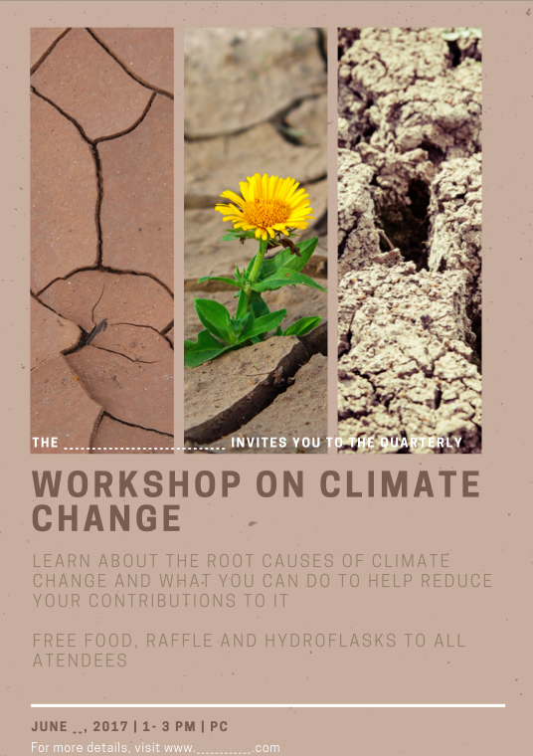

*Figure 1.1 Prototype of Workshop Poster*

We would hope to partner with the UCSD Sustainability Resource Center to get their input and assistance with the presentation of the workshop because they would have the resources to provide speakers and ideas for us. Through this workshop design we hope to attract students from all cultural, economic, and political backgrounds to provide a space where students can learn and access valid information on climate change. The proposed workshop needs to be designed with the awareness that most students who attend it will be financially conscious and will be less likely to implement any advice given if it proves to be too burdensome on their budgets. The information we present would be centered around college student life in hopes that we can affect how they take action for lessening ecological footprints.

KEY ELEMENTS

The workshop is an open and collaborative space for students to come together, learn about climate change, and create a pathway to lessen their ecological footprint. We would encourage social interaction because often discussion leads to ideas people have never thought of. The workshop presents the opportunity for students interested in climate change to come together in a space provided and to build upon each other’s thoughts. There will be moments where we will encourage people to discuss how they work to limit their contributions to climate change and also other novel solutions they have seen regarding the issue. Those who are interested and concerned about the topic will be more vocal and more willing to discuss their feelings, concerns, and potential solutions regarding climate change. Those who are less familiar with some of the concepts or are not as concerned about climate change can ask questions, share their ideas, or simply listen to others at the workshop.

Our main approach to attract students to attend is to incentivize them with food, which will be a successful way to bring in attendance, especially those living on campus. Students will already benefit from getting a free meal, however, they will also receive information to help them understand the causes of climate change and easy steps they can take to help reduce their ecological footprint. The workshop will not only be informative, but also interactive, in order for students to meet and learn from their fellow peers. There will be opportunities to enter raffles for prizes and students will walk out with their very own Hydro Flask, as these new ways of avoiding plastic waste are what characterizes our generation. The overall goal is for students to leave the workshop with new acquaintances, information, goals, and equipment to help them in their journey to living a “greener” lifestyle.

In selecting our key design features, we first looked to needfinding for our human-centered design. Our key features in our first prototype involved student interest, meeting the needs of students from varying interests, and satisfying different kinds of student’s needs. These results shaped our design development by informing us of a refined choice of content for our syllabus and weekly plan. We also paid mind to incentives and rewards by discovering and observing what would make students want to take the course and what would not. We found that many students gave feedback on how to lighten the load of our grade scale in our first prototype. Another key feature was a structured yet flexible individual assignment/journal. We wanted students to personalize the information they learned in the course, track down this information and reflect their awareness in learning about climate change and their creative endeavours in lowering their ecological footprint within their hand-written journals. This came hand in hand with our next key feature, that of engagement, interaction and real-life experience, as we wanted to give students this opportunity to create positive and lasting lifestyle choices and changes that could be of aid to themselves, humanity and the rest of creation around us. Our last key feature was a viable length of time and space for the class. We tried to see if it was necessary to make this a quarter long course or if it was possible to shorten it to be more attractive for students. For example, it could be a seminar of workshops for extracurricular activity credits or for extracurricular experience during college for future employers. These features arose after analyzing the feedback we received from our initial prototype and second parallel prototype on different topic interests, as we realized students would be more reluctant to treat it as important if it were a college requirement for an entire quarter. We found it could be better addressed as a workshop, where students participate because of their individual interest in climate change and wanting to actively aid the planet.

DATA

We used a Day in the Life model to first understand what students at UCSD go through on a daily basis, acknowledging where they go and what devices or programs they use. This helped us to understand where needs are being met in regards to ecological development and where needs are not fulfilled. This also helped us highlight the areas students grow habits and with what means. For instance, during needfinding and looking for inspiration, we looked at how students were recycling and littering, in hopes of formulating a design that can reinvent the way the campus uses, reduces and recycles materials to help reduce waste and toxic emissions from overflowing landfills. We turned to this aspect when seeing an opportunity to become more eco-friendly on campus. This model helped our design development by showing us where students were reinforcing certain habits that increase their ecological footprint. The Day in the Life model helped us hone in on these routines, making them approachable by the team to create a design that could either decrease or eliminate their damaging practices.

Our *Day in the Life* Model illustrates a day in the life of an average UCSD student. We captured certain locations the average student stay in for long periods of time, including the home, campus pathways, the gym, parks, etc. and included subdivisions for great spatial resolution and description of these areas, for instance lecture halls and dining halls. We tagged on each sphere the activities students engaged in in these areas and with what devices, laying out opportunities for us to perceive where certain habits were practiced and where they could be improved or eliminated. The places marked with asterisks in red is where we found poor practices that had potential to impact climate change negatively. At these sites, we could see our problem more clearly to begin a solution designed in accordance with these places, practices, devices and programs used by UCSD students. These problems were circled in red pen to track throughout the model.

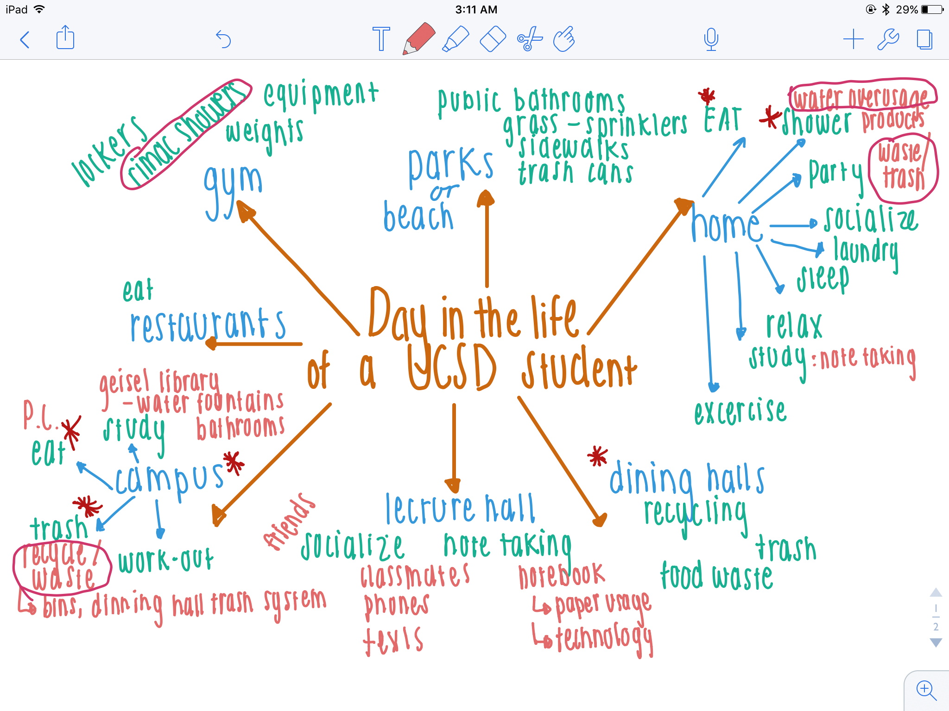

*Figure 1.2 Day in the Life Model*

Our first prototype embodied students interests, as we found positive feedback and approval of our course syllabus design and weekly outline within it. We were able to test incentives and rewards on students as well, as we found preference in less effort or simplified tasks and an updated grade distribution. All our prototypes gave breath to our engagement, interaction and real-life experience feature, as they required students to engage in the course work and then apply the knowledge to a personal project on climate change, allowing students fact learning and interaction with the community and students on campus through their projects. Our initial prototypes and the second parallel prototype of testing interests of different aspects of climate change helped inform our decision of a course to the refined decision of creating a workshop instead.

We tested our prototype by simply presenting students with a syllabus. Although this was easy for both testers and the team, it lacked in being interactive and team could only see the facial reactions testers had while skimming the syllabus. Luckily, the team received insightful feedback and so we overcame this limitation. We then asked questions regarding the overall structure of the syllabus, the likelihood that students would take the class, what we could change to make the class more attractive, and any suggestions to make the class more interactive between peers.



*Figure 1.3 User testing with a UCSD student pointing something out on the syllabus*

Our second prototype was testing different climate change course descriptions through online polls and field studies on UCSD undergrads. We asked testers to rate course descriptions from highest to lowest based on how likely they were to take the class. After the rating was done, we asked questions regarding what course descriptions were more appealing and why. We further followed up with why or why not they felt or didn't feel the desire to take our climate change course. Research methods were similar to the first prototype in that we presented prototype to students and allowed them to interact with it privately. However, it was more physically demanding than simply skimming through a mock syllabus. Limitations included having students read more than they would’ve preferred which resulted in inconsistent feedback.

With the information gathered from both prototypes, we deducted that requiring students to take a course on climate change was too demanding on students who already have heavy workloads and packed schedules. Through the data from prototype two, we uncovered that although students said they would take the class without it being a requirement, this was not in fact true. Students much rather take a class that serves their interests more than a class on climate change. With the interpretation of these results we stepped away from a forceful approach of providing grades to a relaxed alternative. As a team we decided that a workshop would work best for relaying information about causes and effects of climate change to students. Instead of scaring students into attending because they may or may not get an A, we understood that providing a relaxed and fun environment would be more effective to getting students to want to learn about climate change.

By looking at how others solve problems, we learned UCSD supports actions to help climate change with the tagline “Getting zero carbon emissions in the real world”. The school is attempting to tackle the issue from a scientific and technical angle by giving out grants, courses, and seminars that look at topics involving climate change. We learned that even though large scale projects like these are happening all the time, students are not aware of these projects. In addition, there exists a class called SIO 25 that is committed to educating students about climate change. According to the syllabus, they would like to bring students to a level of knowledge that students would be able to accurately explain to others what climate change really is. By following structured projects supported by the school, we can use the same tactics to target the student audience in order to influence and instill a personal change in the student population. In doing this, we can use inspiration from professional scientists and make the same information and habits available to the UCSD population.

DESIGN ADVICE

From our design development process we learned a few factors that could be shared with future designers. We learned that collectively more creativity can arise than brainstorming individually. The sum is often greater than its parts especially in designing. We also learned about the steps of prototyping that can be applied to other situations because it is easy to stall a project by looking into one design or focusing too much on one step, and in the end, not develop the right product. Collaboration in a classroom setting is fun and engaging, and is better than only listening to a lecture because it involves sharing and learning multiple opinions rather than being influenced by just a professor’s opinion. More advice to give to a future designer is to definitely allow oneself to embrace everyone’s ideas and especially become open to others and what they have to offer. Although an individual may believe their solution is the best solution, more often than not, there is more to someone else’s idea that will be missed when personal bias arises. Allow yourself to understand the ideas and full concepts of others, they may be better than your own.

REFERENCES

The Affinity Diagram model helped us organize meaningful feedback from our interviews that we received for developing our initial prototype. This data was organized into physical, social and conceptual spaces in which we heirachrichally placed pieces of our interviews on the board, to view what emotional and intellectual insights gave meaningful guidance to our design development as well as information for our design problem and solution that we had not yet conjured on our own (25, Contextual Design Evolved).

The Day In the Life Model helped the team understand daily patterns and routines of an average UCSD student, in what locations and with what devices. This model helped highlight key sectors and habits students practiced that affected their ecological footprint, either positively or negatively, though we came to find more negative factors through our observations. From these locations, practices and devices we found students use, we were given insight to the design problem and its relevance for UCSD students. This too helped the design development as we saw in what places we should place focus on in order to lower student’s ecological footprints for a positive effect on climate change. (29, Contextual Design Evolved).

Works Cited

"Americans' Knowledge of Climate Change." Yale Program on Climate Change Communication.

N.p., 12 Oct. 2010. Web. 24 Apr. 2017.

[http://climatecommunication.yale.edu/wp-content/uploads/2016/02/2010_10_Americans’-Knowledge-of-Climate-Change.pdf](http://climatecommunication.yale.edu/wp-content/uploads/2016/02/2010_10_Americans%E2%80%99-Knowledge-of-Climate-Change.pdf)

Holtzblatt, Karen, and Hugh Beyer. *Contextual design: evolved*. San Rafael, CA: Morgan &

Claypool, 2015. Print.

Phillips, Melissa C. K., Adam B. Cinderich, Jennifer L. Burrell, Jennifer L. Ruper, Rachel G.

Will, and Scott C. Sheridan. "The Effect of Climate Change on Natural Disasters: A College Student Perspective: Weather, Climate, and Society: Vol 7, No 1." *American Meteorological Society*. Kent State University, 23 Jan. 2015. Web. 22 Apr. 2017. <<http://journals.ametsoc.org/doi/full/10.1175/WCAS-D-13-00038.1>>.

Smith, Joshua Emerson. "UCSD Launches Global Climate Change Initiative."

Sandiegouniontribune.com. N.p., 13 Oct. 2016. Web. 01 June 2017.

Vendituoli, Monica. "Students Fight Climate Change, Cite Personal Reasons." *USA Today*.

Gannett Satellite Information Network, 03 Oct. 2013. Web. 22 Apr. 2017. <<https://www.usatoday.com/story/news/nation/2013/10/03/students-climate-change-reasons/2910737/>>.